Name: ______________________

Position: ____________________

Date: _______________________

Lodge Primary School
E-safety Policy
Infection Control Policy

Roles and responsibilities
Governors: Governors are responsible for the approval of the e-safety policy and for reviewing the effectiveness of the policy.
Head teacher and Senior Leaders: The Head teacher is responsible for ensuring the safety and e-safety of members of the school community. The Head teacher/ Senior Leaders are responsible for ensuring that the Computing Coordinator and other relevant staff receive suitable CPD to enable them to carry out their e-safety roles and to train other colleagues, as relevant. The Head teacher and Deputy Head should be aware of the procedures to be followed in the event of a serious e-safety allegation being made against a member of staff.

Computing Leader: Takes day-to day-responsibility for e-safety issues and has a leading role in establishing and reviewing the school e-safety policy/ documents. Ensures that all staff are aware of the procedures that need to be followed in the event of an e-safety incident taking place. Provides advice for staff.

E-Safety
E-safety encompasses internet technologies and electronic communication such as iPads, digital cameras, mobile phones as well as collaboration tools and personal publishing. It highlights the need to educate pupils about the benefits and risks of using technology and provides safeguards for users to enables them to control their online experience.
E-safety involves pupils, staff, governors and parents making the best use of technology to create and maintain a safe online and ICT environment for Lodge Primary School. It is the duty of the school to ensure that every child in our care is safe, and the same principles apply to the ‘virtual’ or ‘digital’ world. This policy document identifies means for protection for all parties: the students, staff and the school. It aims to provide clear advice on how to minimise risks and how to deal with any infringements. The policy should be read in conjunction with our other safeguarding policies including Child Protection and Anti Bullying/Counter Cyber Bullying. Our policy is in line with the Keeping Children Safe in Education Statutory Guidance 2023.
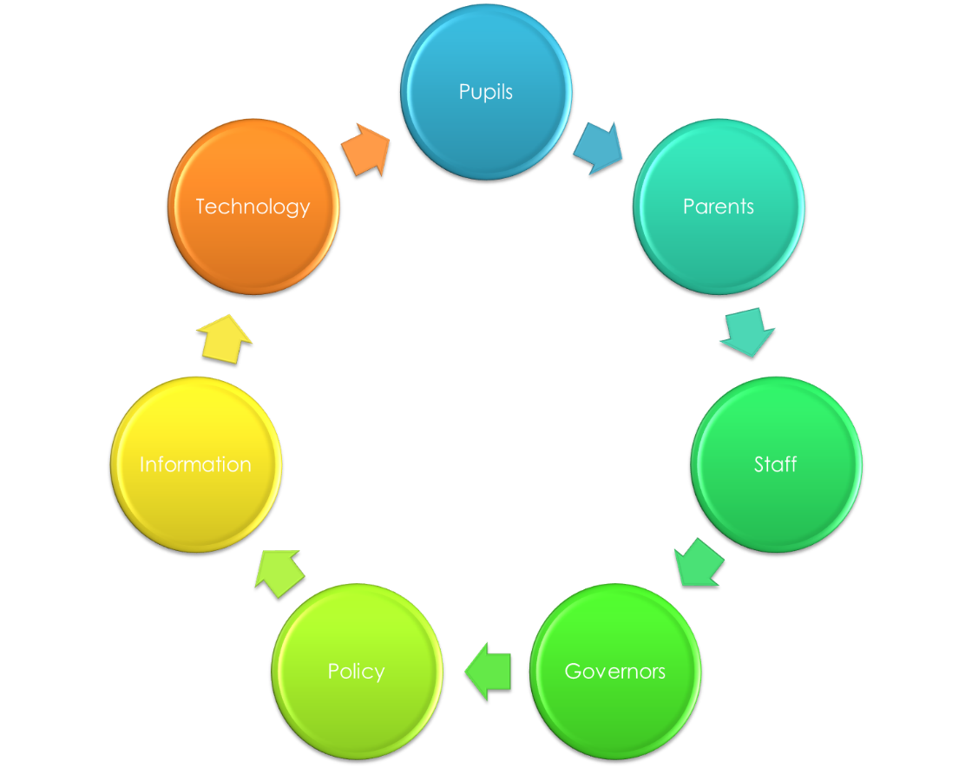



Whole School Approach
Creating a safe ICT learning environment for all users within school includes three main elements:
· Using an effective range of technological tools.
· Ensuring that policies and procedures, with clear roles and responsibilities are shared with students, parents and staff.
· E-Safety teaching is embedded into the school curriculum. Pupils are taught that sharing information with others can be dangerous.

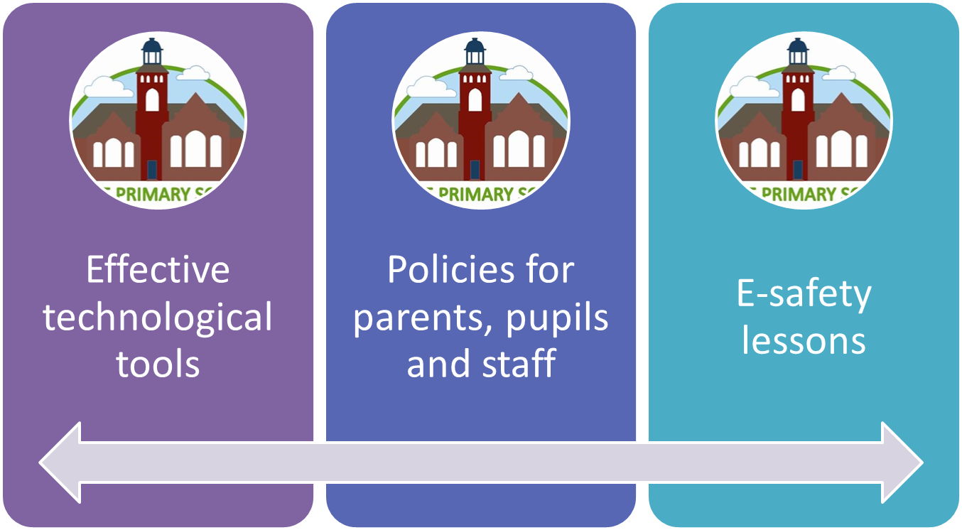

The Internet
The internet is an invaluable resource for learning for all our pupils, and we use it across the curriculum both for researching information and as a source of digital learning materials. As of September 2014, using the internet for learning became part of the Computing Curriculum. At Lodge Primary, we teach all of our pupils how to find appropriate information and how to ensure, as far as possible, that they understand who has made this information available, and how accurate/ truthful it is.
We encourage pupils to see the internet as a rich and challenging resource, but we also recognise that it can be difficult to navigate and find useful and appropriate material. Where possible, and particularly with younger children, we provide pupils with suggestions for suitable sites across the curriculum, and staff always check the suitability of websites before suggesting them to children or using them in teaching.
Uses for the internet at Lodge Primary:
· The internet is used by teachers, who carefully plan all internet-based learning to ensure that pupils are focussed and using appropriate and relevant materials.
· Children are taught how to use search engines and how to evaluate internet-based information as part of the Computing Curriculum, and in other curriculum areas too.
· Pupils learn how their work can contribute to the school’s website and how they can develop and share ideas with others.
Internet access is carefully controlled by teachers according to the age and experience of the pupils, and the learning objectives being addressed. Pupils are always actively supervised by an adult when using the internet. In line with our inclusion policies across the school, we want to ensure that all our pupils have access to the internet, particularly where this will directly support their learning. The school uses the local authority filtering system to ensure that the risk of accessing inappropriate content is minimised. However, if staff or children access unsuitable sites, they must report it to the teacher who will then report to a designated safeguarding leader. The school also purchases the Smoothwall monitoring system to support our e-safety systems.

Teaching safe use of the Internet and ICT
We think it is crucial to teach pupils how to use the Internet safely, both at school and at home, and we use the UK safer internet safety centre to support our teaching in this area. Uk safer internet centre have a partnership between Childnet International, Internet Watch Foundation and Southwest Grid for Learning.
The main aspects of this approach include the following five SMART tips:
· Staying safe involves being careful and not giving out your name, address, mobile phone number, school name or password to people online.
· Meeting someone you meet in cyberspace can be dangerous. Only do so with your parents'/carers' permission and then when they are present.
· Accepting e-mails or opening files from people you don't really know or trust can get you into trouble - they may contain viruses or nasty messages.
· Remember someone online may be lying and not be who they say they are. If you feel uncomfortable when chatting or messaging end the conversation...
· Tell an adult if someone or something makes you feel uncomfortable or worried.
Children are taught about cyber-crimes including how to minimise being exposed to harmful risks.

Cyberbullying
Online bullying and harassment via instant messaging, mobile phone texting, e-mail or chat rooms are potential problems that can have a serious effect on pupils. Our school has a range of strategies and policies to prevent online bullying, including:
• Forbidden access to public chatrooms, instant messaging services and video access.
· Pupils are taught how to use the internet safely and responsibly, and are given access to guidance and support resources .
· We encourage pupils to discuss any concerns or worries they have about online bullying or harassment with staff.
· Complaints of cyber-bullying are dealt with in accordance with our Anti-Bullying and Counter Cyber Bullying Policies.
• Complaints related to child protection are dealt with in accordance with school child protection procedures.

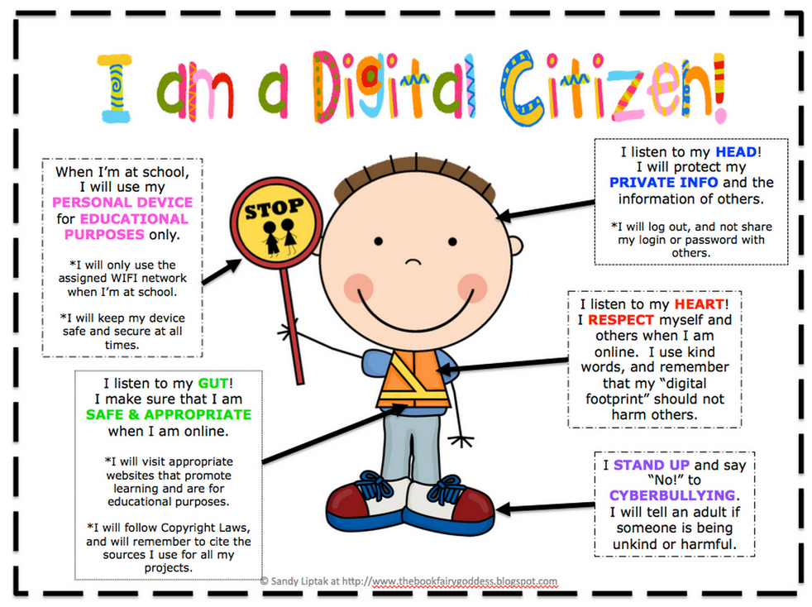

Website
The school website is a valuable source of information for parents and children. Staff must be aware that:
· The contact details on the website will be the school address, e-mail and telephone number, no individual email addresses will be available.
· Staff and pupils’ personal information will not be published.
· The Head teacher will take overall editorial responsibility and ensure that content is accurate and appropriate.
· Photographs and videos that include pupils will be selected carefully.
· Pupils’ full names will not be used on the website, particularly in association with photographs.
· Consent from parents will be obtained before photographs of pupils are published on the school web site.
· Work can only be published with the permission of the pupil and parents.
As part of the school’s computing and wider curriculum, pupils may be involved in designing and evaluating web-based resources. Any work that is published on the school’s website will reflect our school, and will therefore be checked for mistakes, inaccuracies and inappropriate content.
The website link is www.lodgeprimaryschool.co.uk

Teaching and Learning
The internet opens new opportunities and is becoming an essential part of the everyday world for children. Internet use is a part of the statutory curriculum and a necessary tool for staff and pupils and so the school has a duty to provide pupils with quality internet access as part of their learning experience: In line with KCSIE 2023.
· The school internet access is designed expressly for pupil use including appropriate content filtering. The filtering system we use is provided by our internet provider, LGfL (London Grid for Learning). We use Smoothwall Policy Central Forensic software at Lodge.
· Pupils are given clear objectives for internet use and taught what is acceptable and what is not.
· Pupils are educated in the effective use of the internet in research, including the skills of knowledge location, retrieval and evaluation.
· As part of the computing curriculum, all year groups have digital literacy units that focus on different elements of staying safe online. These units include topics from how to use a search engine, our digital footprint and cyber bullying. The curriculum is taught through a programme called, Teach Computing. Through Teach computing, we teach E-safety throughout the whole of the computing curriculum.
· The school ensures that the use of internet derived materials by staff and pupils complies with copyright law.
· When children are directed to websites as part of home learning tasks, they will have been checked by the teacher setting the learning.
Through computing, we ensure that the school meets the needs of all, taking account of gender, ethnicity, culture, religion, language, sexual orientation, age, ability, disability and social circumstances. It is important that in this school we meet the diverse needs of pupils to ensure inclusion for all and that all pupils are prepared for full participation in a multicultural society.
Throughout the curriculum children will be taught about cyber-crime and how to be vigilant against cyber criminals. As the digital age grows, it is the responsibility of the computing leader to keep up to date with new cyber-crime trends to support staff and students with new technologies.

Remote learning
In the event of school closure (for example, pandemic/severe weather) we will move to remote learning. The school will use Google Classroom to set and respond to learning. E-safety continues to be an important feature of our remote curriculum.

· Classroom pages will be regularly monitored by the computing lead and the senior leaders.
· The ‘Stream’ (where children can post public comments) will only be activated during school hours when staff will monitor the content and can flag up anything inappropriate.
· Children will be reminded of the SMART rules for Internet use.
· Any links to support learning will be checked by staff.
· As a school we will not link to YouTube videos. YouTube videos can be used if appropriate but only if they have been downloaded and uploaded to Google Classroom.
· Parents will be reminded of the importance of online safety in line with government advice.
The use of ClassDojo is used for parent teacher communication to help promote a support behaviour in school. This is linked to our behaviour policy. ClassDojo is set up for only this use. IT will not be used

Technological Devices
Due to devices having access to the internet and picture and video messaging, there are opportunities for data sharing. Therefore, there are risks of mobile bullying and safeguarding issues. Each year pupils and parents are asked to sign an acceptable use policy for the laptops and mobile devices within school. In addition to this, pupils are discouraged from bringing mobile phones to school and are only allowed to do so in certain circumstances. See also Acceptable Use of Mobile Phone policy and the sending of abusive or inappropriate text messages is forbidden.
· Staff including students and visitors are not permitted to access or use their mobile phones within areas used by the children. See also Acceptable Use of Mobile Phones policy.
· Staff may use their mobile phones in the staffroom during the lunch period and at other times should be stored safely away.
· Parents may not use their mobile phones, or other technological device to take photos of children during assemblies.
· Pupils should not use mobile devices and laptops at school unless authorised by staff.
· Publishing of images, video and sound will follow the policy set out in this document under the School Website section.

Policy Communication
Pupils
· Rules for internet access will be posted on laptop/iPad trollies.
· Pupils will be informed that internet use will be monitored.
· Pupils will be informed about the importance of e-safety half termly throughout school from Year One during Computing lessons, assemblies and other related activities. EYFS are also taught about e-safety, and discuss this in their lessons.
· All year groups will look at different areas of safety through our curriculum.
Staff
· All staff will be given the school E-Safety Policy and its importance explained.
· Staff should be aware that internet traffic can be monitored and traced to the individual user. Discretion and professional conduct are essential.
· Staff and governors are cyber security trained. This is reviewed yearly.
Parents
· Parents’ attention will be drawn to the school’s E-Safety Policy in newsletters and on the school website.
· Parents will be given the option of allowing their child to feature on the school’s website and may decline if they so wish. Staff follow the guidelines set out in the General Data Protection Regulations 2018.

E safety Risks
The school will take all reasonable precautions to prevent access to inappropriate material. However, due to the international scale and linked Internet content, it is not possible to guarantee that unsuitable material will never appear on a school computer. The school does not accept liability for the material accessed, or any consequences of internet access. The school will audit IT use to establish whether the E-safety policy is adequate and whether the implementation of the E-safety policy is appropriate.
Complaints
· Complaints regarding internet misuse will be dealt with by a senior member of staff.
· Any complaint about staff misuse must be referred to the Head teacher or the Chair of the Governing Body in the event that they are unavailable.
· Complaints of a child protection nature will be dealt with in accordance with the school’s child protection procedures.
· Discussions will be held with West Midlands Police and the LADO, to establish procedures for handling potentially illegal issues. See also Child Protection, Safeguarding policy and staff conduct policy.
Social Media
The school does not permit the pupils to access their private accounts on social or gaming networks at any time during the school day.
Many social networking websites have minimum age limits. To use WhatsApp you must by over the age of 16 and to use ‘Snapchat’, ‘Facebook’ or ‘Instagram’ you must be over the age of 13. The school also strongly discourages children from using age-inappropriate social networking outside of school. Should the staff be made aware of incidents or activities on these social networks, which has a direct effect on the children’s behaviour or attitudes within school, then the school reserves the right to act regarding their accounts. This may include discussions with parents, information letters or reporting the child’s access to the respective organisations/companies
Sexting
Someone taking an indecent image of themselves and sending to their friends or boy / girlfriend via a mobile phone or some other form of technology is sometimes referred to as ‘sexting’. Young people need to be aware that they could potentially be distributing illegal child images. Staff working at Lodge Primary School will ensure that they are aware of the risks associated with the use of the internet and how to respond appropriately to a ‘sexting’ incident. We know this can cause enormous distress to children and young people and may place them at risk of sexual grooming and other risks associated with the internet.

Review: March 2025
Next review: Spring term 2026

